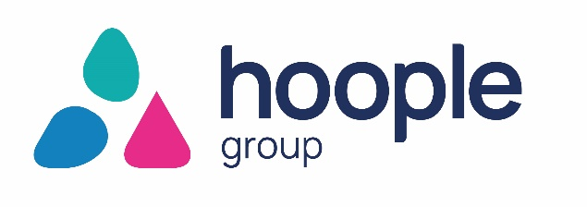

Gender Pay as of 5 April 2025

Introduction
Hoople Group is a public sector-owned company that provides support services to the public sector as well as commercial customers and is required to report on its gender pay gap and gender bonus gap.
The gender pay gap is an equality measure to show the difference in earnings between women and men.
The Office for National Statistics reports that for all employees in the UK, the gender pay gap in April 2025 decreased from 13.1 % to 12.8%.
The gender pay gap does not show the difference in pay for comparable jobs; unequal pay has been illegal since the introduction of the Equal Pay Act, 1970.
Hoople operates a formal job evaluation scheme that ensures pay and grading of jobs is fair and non-discriminatory.
Hoople is a unique organisation providing a range of support services to its shareholders and other customers, and its pay structure covers a range of diverse services. Pay grades vary according to the level of responsibility and each grade is made up of several incremental points. Discretionary increments are awarded on an annual basis as determined by EMT until the employee reaches the top of the grade.
In line with the Government requirements, Hoople must calculate and report the following six calculations:
- Percentage of men and women in each hourly pay quartile
- Mean (average) gender pay gap using hourly pay.
- Median gender pay gap using hourly pay.
- Percentage of men and women receiving bonus pay.
- Mean (average) gender pay gap using bonus pay.
- Median gender pay gap using bonus pay.

Workforce demographic
As of 5 April 2025, Hoople had 613 relevant employees as per the definition of the statutory gender pay gap guidance to report; of which 180 were men and 433 were women. The hourly rate for full pay is included in the calculations, meaning that only those employees receiving their full or ordinary pay for the period are included in the calculations.
Employees per quartile
The 581 full-pay relevant employee data was sorted from highest to lowest by hourly pay and split into quartiles. When the data was organised, it was determined that per quartile the percentage of men and women in each quarter was as shown in the graph below:
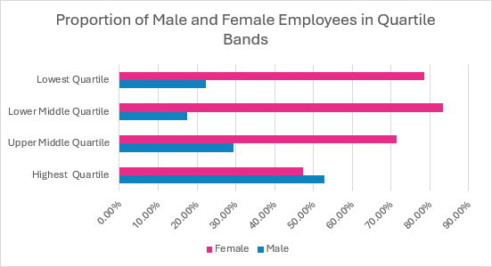
The Mean Gender Pay Gap (hourly rate)
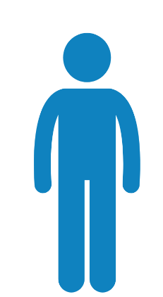  £18.66 | 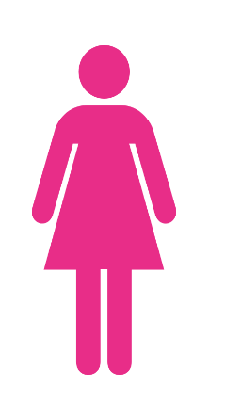  £15.29 |  | The mean gender pay gap equates to 18.06%. This means for that for every £1 a male employee earns, a female earns 82p.

The Median Gender Pay Gap (hourly rate)
£16.52 | £13.75 |  | The median gender pay gap equates to 16.77%. This means that for every £1 a male employee earns, a female employee earns 83p.

The Government asks employers to calculate both the mean and the median pay gap. However, it is the median figure that tends to be reported and used for comparisons as this does not get distorted by exceedingly high or low numbers.
The median pay gap has increased from the 2024 figure of 15.21%. The 1.56% increase in the median gender pay gap is primarily driven by a higher proportion of new male recruits entering the upper-middle pay quartiles, combined with a concentration of female staff in roles within the lower pay bands. While median pay rose for all employees, the rate of increase for male staff outpaced that of female staff due to these structural shifts in workforce distribution.
The graph below shows how the median gender pay gap has fluctuated since Hoople started reporting gender pay gap.
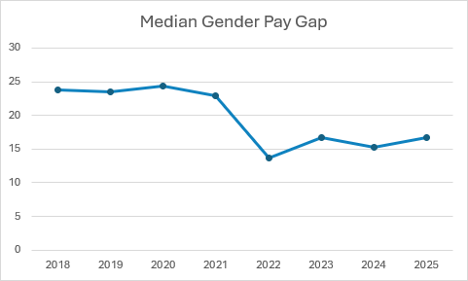

Gender Bonus Pay Gap
Hoople have a company bonus as part of the terms and conditions of employment. All eligible employees are awarded the company bonus on an annual basis. The value of the bonus is £250 minimum subject to Board approval. The definition of a bonus for Gender Pay Gap reporting includes payments such as one-off additional payments awarded for specific contributions as well as welcome payments and vouchers.
For reporting, Government guidance states that the Gender Bonus Pay Gap is reported on a period over 12 months, so for this year’s calculation the period used is April 2024 to March 2025 and the figures capture the payments made to employees during this period, relating this this period.
During this period, 180 male employees (100%) received a relevant bonus payment and 429 (99.08%) female employees received a relevant bonus payment.
The Gender Bonus Pay Gap does not refer to an hourly rate, but rather to the total payments made over a given period. Since a range of factors are considered when calculating bonus payments, the proportional value of these payments can be influenced by a combination of elements that affect whether and how these bonuses are awarded.

The Mean Gender Bonus Pay Gap
£448.94 | 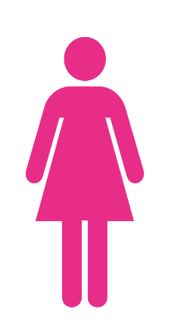  £344.70 |  | The Mean Gender Bonus Pay Gap equates to 23.22%. This is a direct result of our inclusive bonus scheme. In 2025, every eligible employee received a £30 voucher regardless of hours worked, and a £500 one-off payment which was pro-rated for part-time staff. As a high percentage of our part-time workforce are female, the pro-rating of the cash element naturally results in a lower average bonus for women when compared to full-time male colleagues. If these figures were adjusted to a full-time equivalent (FTE) basis, the bonus gap would be 0%.
The Median Gender Bonus Pay Gap
£530 | 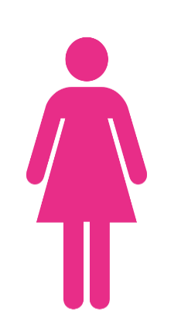  £356.03 |  | The Median Gender Bonus Pay Gap equates to 32.82%. This figure is a mathematical representation of our workforce structure; our median male bonus of £530 reflects a full-time working pattern, while our median female bonus of £356.03 reflects the pro-rated payments received by our significant part-time female workforce. This gap does not indicate a difference in bonus opportunity, but rather the difference in total hours worked by the 'middle' employee of each gender.

How Hoople Compare
In England and Wales, there is an overall median pay gap of 13.1% for all employees, as reported by the Office for National Statistics (ONS) in 2024/25. This figure spans all industry sectors and includes both full-time and part-time workers. This indicates that, nationally, women earn approximately 87p for every £1 earned by a man. The following table provides further context by comparing Hoople’s 2025 median gap of 16.77% against the most recent available data from partner organisations and regional benchmarks.

Organisation | Median Pay Gap – i.e. Women’s hourly pay is:
Herefordshire Council | 10.4% lower
Worcestershire County Council | 6.7 % lower
Shropshire Council | 7.3% lower
Wye Valley NHS Trust | 16% lower
Geographical comparisons  West Midlands, all sectors | 15% lower
Industry comparison  UK Public Sector | 13.1% lower

Organisational Context
For the 2025 reporting period, Hoople’s median gender pay gap is 16.77%. While this is a marginal increase from 2024, analysis confirms that this is not due to paying male and female employees differently for the same work. Instead, it reflects the structural distribution of our workforce and the roles that men and women currently occupy.
Our gap is significantly influenced by broader societal factors and our success as a flexible employer of choice.
- Recruitment Trends: Of the 132 new hires this year, 71% (94) were women who joined the organisation in lower-paid roles. This influx of female talent at the entry-level mathematically impacts the median pay calculation.
- Vertical Distribution: As demonstrated in the "Hoople Bands" chart below, we have a high concentration of female employees in our lower earnings quartiles (Bands A-C). While we have more females than males across almost all quartiles, the Highest Quartile is the only band where men hold a majority (52.74%).
Hoople offers a wide range of family-friendly policies, including hybrid working, term-time only positions, and career breaks. While these are available to all, they are disproportionately utilised by our female workforce.
- As of April 2025, 89% of our employees working part-time hours are female.
- This heavily affects our 32.82% median bonus gap. Because our 2025 recognition payment was pro-rated for part-time staff, the cash value received by our predominantly female part-time workforce was naturally lower than that of full-time counterparts, despite 99% of women receiving the award.
Opportunity to close the gender pay gap is currently limited by the high number of women occupying, and being attracted to, entry-level and part-time positions. Hoople remains committed to ensuring that while we provide entry points and flexibility for women, we are focussing on internal progression pathways via a talent framework which may enable our female talent to move into the higher pay bands (D and above).

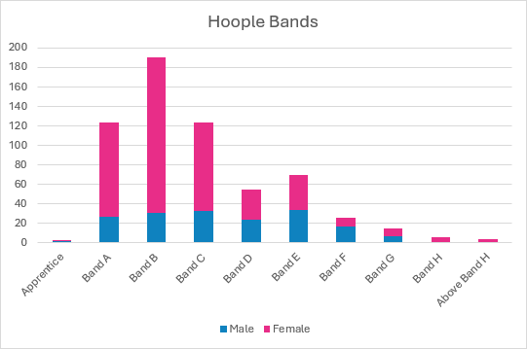
Actions to address Hoople’s Gender Pay Gap
Hoople is committed to eliminating discrimination in all its forms. Our Board and employees work diligently to ensure that equity, inclusion, and wellbeing are not just policies, but the core of our operations. We actively challenge conscious and unconscious bias in our decision-making to ensure fair representation across every level of the company.
We strive to create a healthy, high-performance culture where excellence is celebrated and professional development is accessible to all. We support the diverse needs of our workforce through:
- Agile & Flexible Working: We champion hybrid working and flexible hours, ensuring all flexible working requests are managed fairly and without bias.
- Wellbeing: We provide a robust support network, including Mental Health First Aiders and additional health services via our dedicated rewards platform.
- Generous Leave Provisions: We reward loyalty with 31 days of annual leave (after five years) and offer a "Holiday Purchase" scheme to further support work-life balance.
- Continuous Learning: All staff and managers undergo mandatory Equality, Diversity, and Inclusion (ED&I) training to ensure our culture remains inclusive, learning and development discussions also take place within our annual review cycle (ARC).

By prioritising these benefits, Hoople remains an excellent local employer. While our high volume of part-time female staff creates a mathematical challenge for our gender pay gap reporting, these same flexible policies are what allow us to retain high-calibre talent who might otherwise be excluded from the workforce.

The below actions have been identified to help address Hoople’s gender pay gap:

Action

Please note that there is a gender pay gap action plan which also tracks actions achieved to date.

- Manager training sessions to include flexible working and job design to ensure managers understand and consider how more senior and technical roles can be undertaken by part time or job share positions.

- Track grievances/appeals relating to flexible working requests, broken down by gender, with appropriate review and action taken.
- Utilise data from various listening tools, such as the pulse survey to measure ‘promotion confidence’ and link to CPD/ mentoring opportunities.

- Report the gender of candidates shortlisted following a job application, challenge to ensure there is no unconscious bias in the process
- Promote career development programmes to entry level employees to increase the appointment of diverse and representative middle/senior management roles (establish talent framework)
- Launch a recruitment de-bias toolkit to ensure a fair and inclusive recruitment process.
- Review and update the Equality, Diversity, and Inclusion (ED&I) training and policies to reflect the recent Worker Protection Act (WPA) legislative changes and upcoming relevant Employment Rights Bill changes, including sexual harassment and day one rights.
- Work with at least two local colleges/schools’/careers events to promote women in STEM careers. Increasing the number of women who are shortlisted for roles, increases the chance of appointing a woman into posts where women are underrepresented. Attracting more women to apply for these roles is the first step to increasing the number of women shortlisted.
- Conduct an internal shadow report of the 2025 bonus pay gap to demonstrate the true outlook of a <5% bonus pay gap when adjusted for FTE

I confirm that the data reported is accurate.
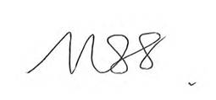
Nicola Twigg
Chair, Hoople Board

